SOP – Research Project 2 Neural signal Processing & Machine Learning for Neural Decoding

**SOFTWARE DOWNLOAD**

1. Log into the canvas course page. Access the Research Project 2 module and download the folder “Research Project 2”
2. Extract to your documents folder. You will have access to these files when you log into your CADE account, both remotely and on a CADE lab computer.
3. Once again for this lab, there are only a couple of sections you need to add your own code. You can if you wish go into the other sections, or functions and edit it to your liking.
4. Open the folder has 3 files that you need to open:
   1. notebook_01_project_overview.mlx
   2. notebook_02_preprocessing_and_feature_extraction.mlx
   3. notebook_03_ann_training.mlx

**Using MATLAB Livescripts**

Livescripts are a MATLAB feature that allows you to combine code, with formatted text and images. When you open the livescripts for the first time, make sure you select the “Output Inline” option located on the side of the “Live Editor”.

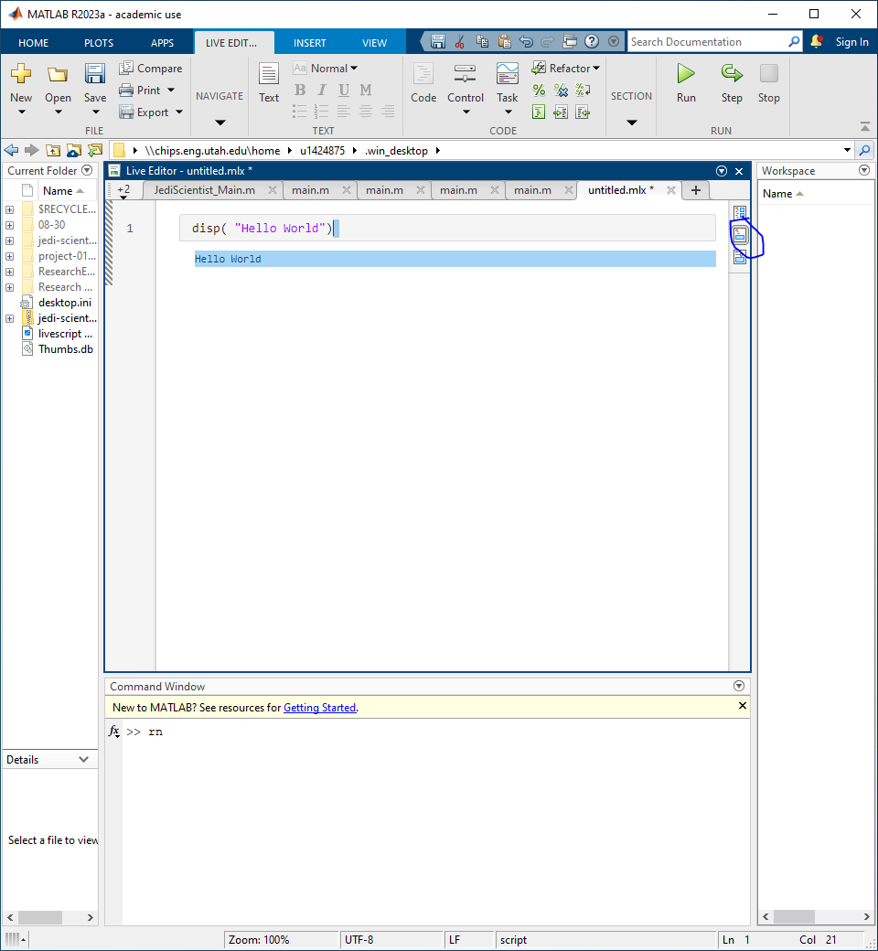

Sections are indicated by blue lines, and to run each section, click on the live editor and the use the button “Run Section”

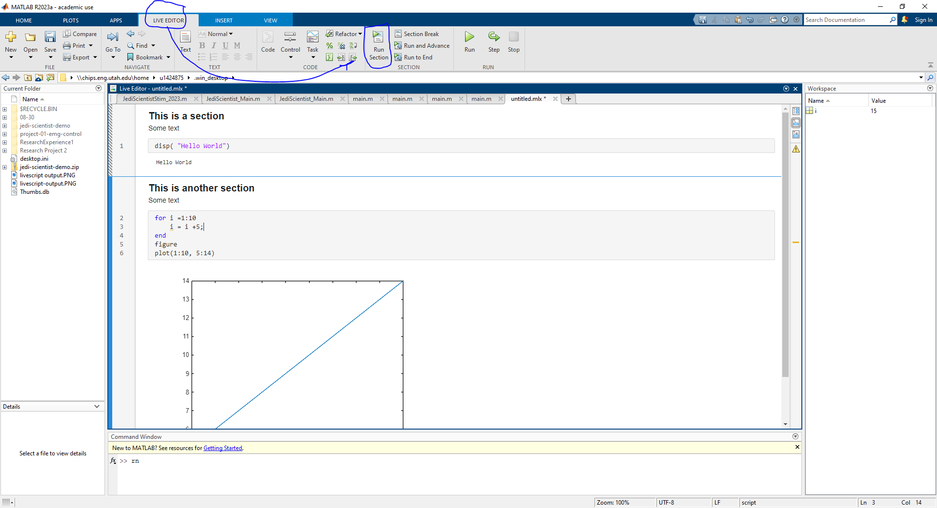

Finally, when plotting, you can open plots in a new window by hovering over the image and clicking the gray arrow on the upper left corner.

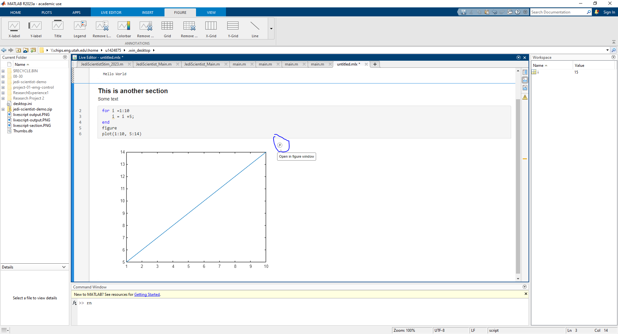

**Notebook 01: Project Overview**

The goal of this notebook is to get you familiarized with the dataset, how it is stored, as well as the research goals. You won’t modify any code in this notebook

**Notebook 02: Preprocessing and Feature Extraction**

In this notebook you will need to modify the code enclosed by comments in this style:

%%%%%%%%%%%%%%%% CHANGE THIS CODE %%%%%%%%%%%%%%%%

code_that_needs_to_change()

%%%%%%%%%%%%%%%%%%%%%%%%%%%%%%%%%%%%%%%%%%%%%%%%%%

Code not enclosed in those comments can be executed without modifications.

**Preprocessing - Step 1: Load Data**

1. This is done in the first section. The variable loaded will be a struct named training data containing the kinematics of a prosthesis, unfiltered neural data, and the sample rate at which both were recorded. The unfiltered data will also be plotted in **Step 2.**
   1. Debugging tip: If this section fails, verify MATLAB’s working directory and set it the folder Research Experience 2 in your Documents folder.

**Preprocessing - Step 3: Filter data- Your code goes here**

1. In this section you will figure out what filter to use for the neural data. After you filter it, the filtered data will be plotted in **Step 4**. You will likely want one of the subplots for your paper.
   1. Debugging tip: If this section fails, verify all the needed files are included in the working folder. Check the comments in the first section for a clue on the values you need to change.

**Spike Detection – Step 1: Your Code goes here**

1. Goal is to find where the signal shows a neural spike.
2. Goal of this section should be to find a logical array of where the spikes occur within each channel.
3. That is what will be passed to visualize the waveforms of the spikes in the **Steps 2 and 3.**

**Spike Detection - Step 4: Calculate the Signal-to-Noise ratio (SNR)**

1. There is a for loop in this section to help you access all the spikes that were generated with your spike detection algorithm.
2. Calculate SNR, create figures and run statistics on the SNR for the different channels of neural signal.

**Feature Extraction - Your Code goes here**

1. In this section you will decide how to use the information you found in earlier, store in a variable called neural features and then save that variable to the results folder in your workspace.

**Notebook 03: ANN Training**

**Step 3C: Train the neural network**

1. In this section you have a neural network given to you. The only two variables you need to change will be learnRate and maxEpochs. These variables will affect how long and how fast the network trains.
2. You are allowed to adjust the network as you see fit in **Step 3B.**

**Step 4: Test Neural network against unseen data**

1. In this section you will use the trained neural network to predict kinematics from the test data you were given.
2. You will be required to repeat the filtering and additional steps you did on the earlier data to generate the features before testing the trained neural network.
   1. Debugging tip: If copying and pasting your code, make sure to edit the variable names correctly so that you get the features for the testing data rather than just repeating the process with the data using for training.

**OBJECTIVE (FROM CANVAS!)**

Your objective is train an artificial neural network to map neural data to the intended kinematics of an individual. At your disposal is 5 channels of neural data recorded from Utah Slanted Electrode Arrays implanted into the residual median arm nerve of an amputee participant. You will also have intended kinematic data (i.e., intended movements of grasping and wrist movement) recorded in synchrony with the neural data. You have also been provided with MATLAB code for loading the data, visualizing the data, and training and testing an artificial neural network. To complete your objective, you will need to convert neural data into useable neural features. This means you will have to detect spikes and determine neural features that correlate with the intended kinematics. You will first detect spikes and determine the signal-to-noise ratio of the spike waveforms. Then you will explore TWO different approaches to calculating neural features.

**GETTING STARTED IN LAB**

Before lab, reread the information on Canvas! It specifically tells you the key components of what you are doing, “To complete your objective, you will need to convert neural data into useable neural features. This means you will have to detect spikes and determine neural features that correlate with the intended kinematics. You will first detect spikes and determine the signal-to-noise ratio of the spike waveforms. Then you will explore TWO different approaches to calculating neural features.” Next review the rubric. It specifically tells you what you will be graded on. Take Note of what figures you need to generate for your project as that is where most of your work will be.

1. Figure 1 will be a figure of the implanted device (i.e., a Utah Slanted Electrode array), which you can find in a previous publication about the device (remember to cite the paper you found the figure from!).
2. Figure 2 will be an overview of the filtering and spike detection performed. You will select one channel to highlight and show transition from raw signal, filtered, and example neural unit waveforms. Be sure to include time scales for each part of the figure!
3. Figure 3 is a boxplot or barplot of the SNR for the recorded electrodes.
4. Figure 4 is a two-part figure. Part 1 is for the neural Features, and Part 2 is for the Kinematic Predictions.
5. Figure 5 is a barplot or boxplot of the performance metrics of your choosing. You should define your own metric, do a head-to-head comparison of the two different methods you used to calculate the neural features and their impact on the neural network predictions.